SIMATS ENGINEERING
ASSESSMENT TOOL 3

COURSE CODE: CSA1407 COURSE NAME: Compiler Design

COURSE OUTCOME COVERED

CO2: Construct top-down and bottom up parsers using CFG for parsing conflicts and error recovery for efficient syntax tree generation. (BL3)

Assessment Tool Weightage: 10%

QUESTIONS: Total Marks:50

Annexure A

SCENARIO BASED TASK

Code of Conduct:

I _____M.Madhu Rushwika(192371066)_________________ certify that this submission is my original work and that I have adhered to the guidelines specified for this assessment.
I understand that any violation of academic integrity rules will result in disciplinary action.

Signature of the student: M.Madhu Rushwika

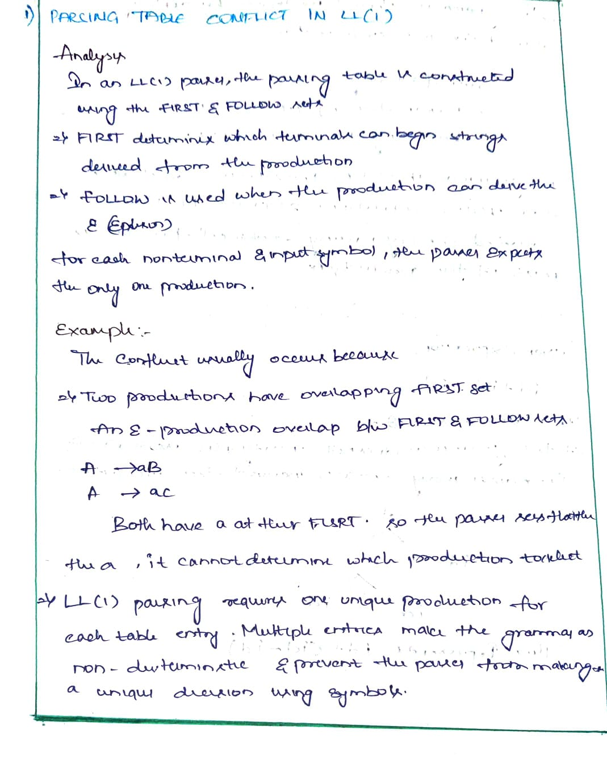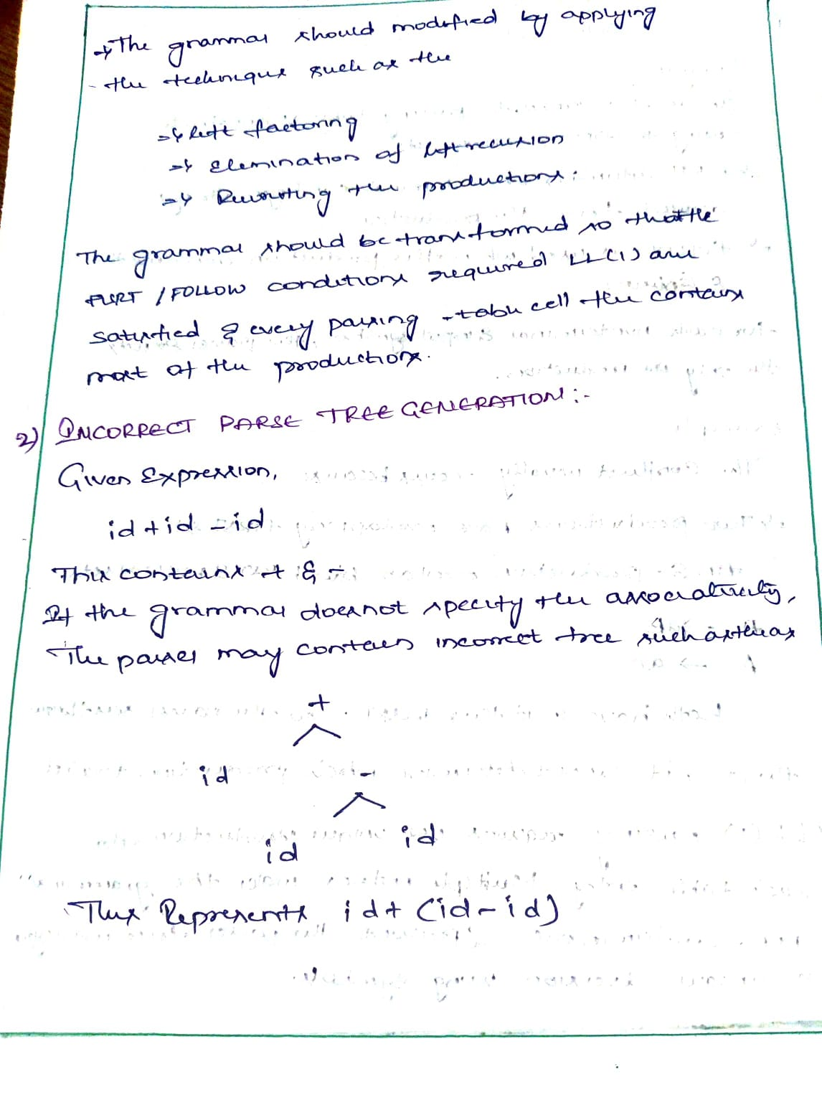

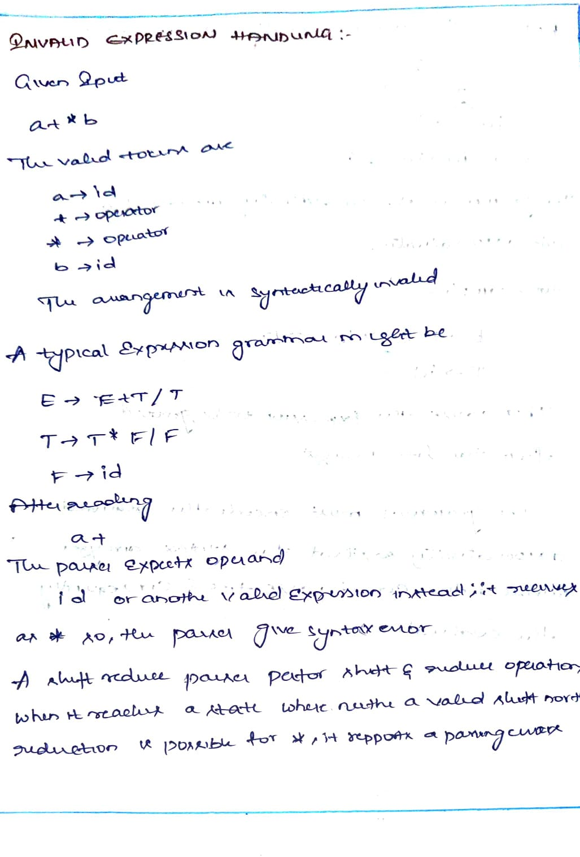

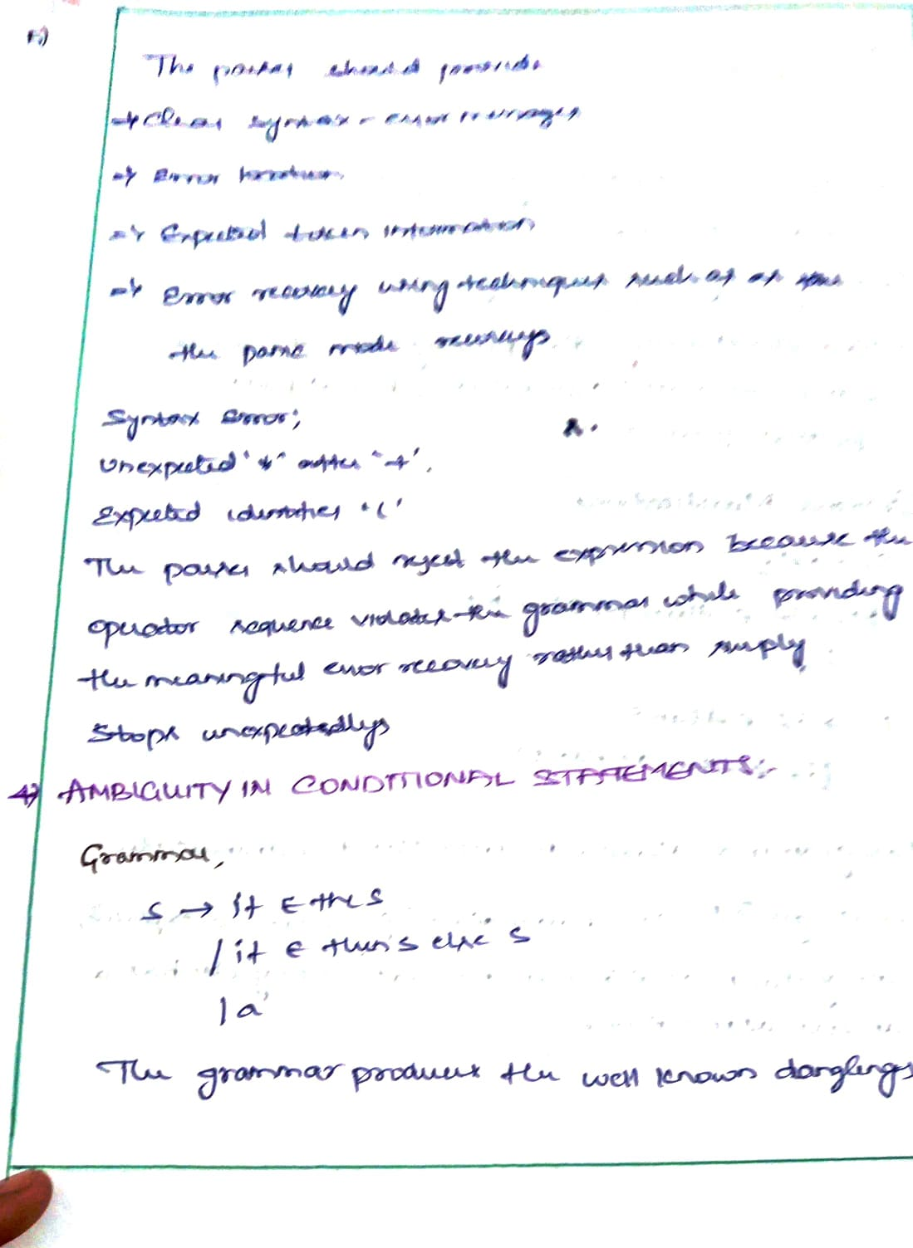

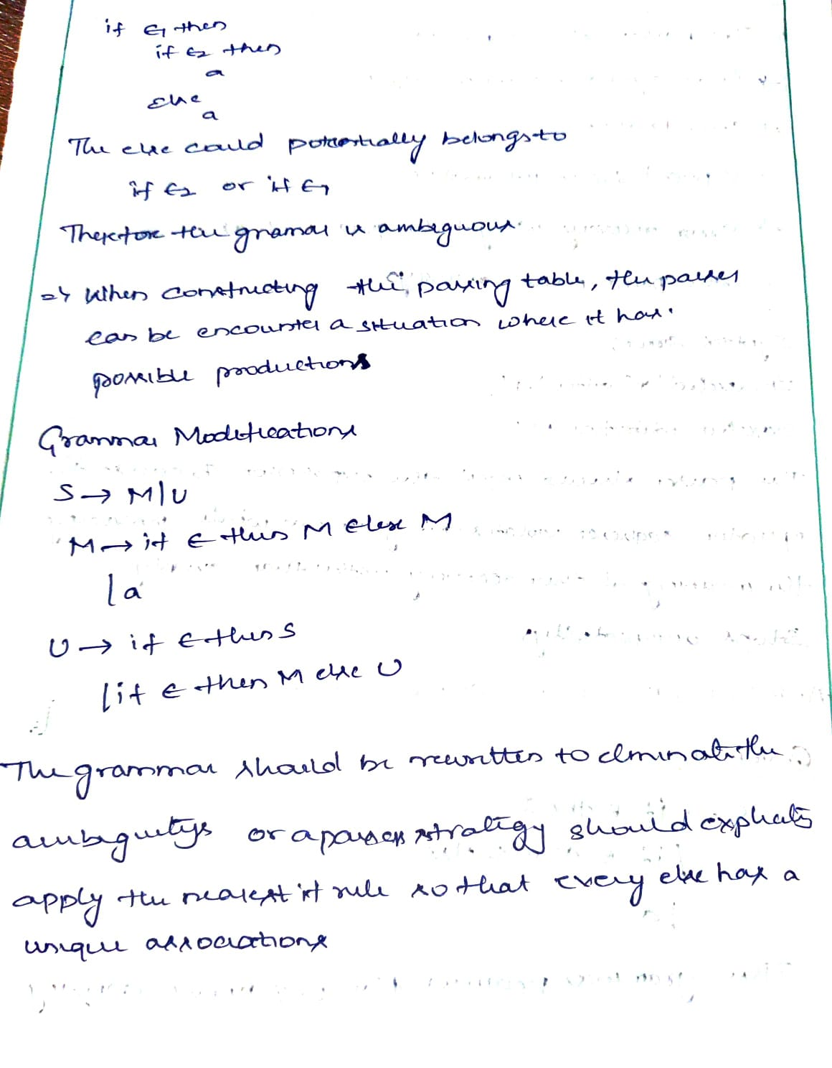
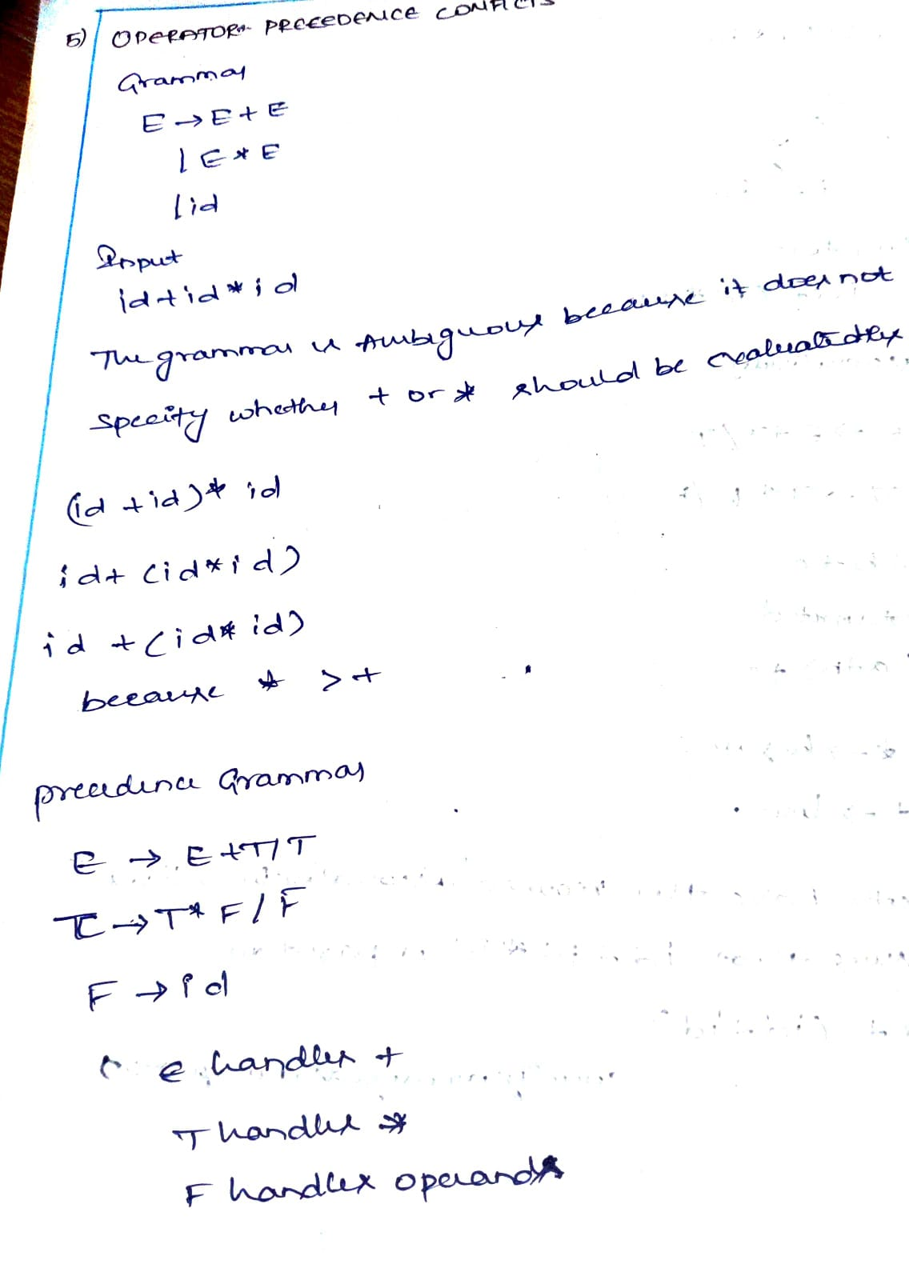


RUBRICS FOR CALCULATION:

Scenario based assessment
Criteria | Weightage (%) | Level 4 (Exemplary) | Level 3 (Proficient) | Level 2 (Developing) | Level 1 (Beginning)
Understanding of Scenario | 20% | Demonstrates clear and complete understanding of the scenario and context | Shows good understanding with minor gaps | Partial understanding; misses key aspects | Misinterprets or fails to understand the scenario
Identification of Key Issues | 20% | Accurately identifies all relevant issues and factors involved | Identifies most key issues with minor omissions | Identifies limited issues; some irrelevant points | Unable to identify key issues
Application of Concepts | 25% | Applies appropriate concepts effectively to address the scenario | Applies concepts with minor errors | Limited or partially correct application | Unable to apply relevant concepts
Decision Making | 20% | Makes well-reasoned, logical decisions with strong rationale | Makes reasonable decisions with some justification | Makes weak decisions with limited justification | No clear decisions made or rationale provided
Clarity of Response | 15% | Response is clear, structured, and logically presented | Generally clear with minor issues | Somewhat unclear or poorly structured | Disorganized and

